**What is DHCP?**rfc2131

DHCP is used to control the network configuration of a host through a remote server. DHCP functionality comes installed as a default feature in most of the contemporary operating systems. DHCP works on a client-server model. DHCP uses UDP as its transport protocol and has it’s own set of messages that are exchanged between client and server. Here is the header information of DHCP :

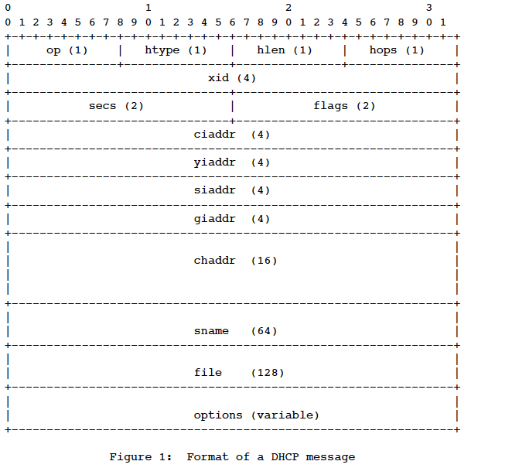

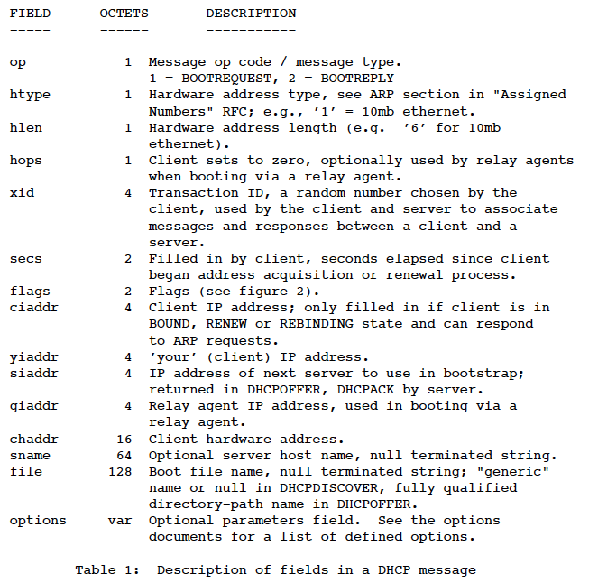

**1. DHCPDISCOVER**

It is this DHCP message that marks the beginning of a DHCP interaction between client and server. The client sends this to the subnet it is connected to. It’s a layer two (Ethernet) broadcast message that uses FF:FF:FF:FF:FF:FF as the destination address and the Mac address of the requesting client. This Ethernet frame carries a layer 3 message (IP) who sources address is 0.0.0.0 and destination address 255.255.255.255. The IP packet carries a message to UDP Port 67 (DHCP) of type Discover from UDP Port 68.

**2. DHCPOFFER**

A DHCP server sends this DHCP message in response to a DHCPDISCOVER to a DHCP client. This message contains the network configuration settings for the client that sent the DHCPDISCOVER message. If there is no replay to this request with a short timeout then the offer is rescinded. The timeout from the source code is 2 minutes but many DHCP servers can configure this as an option at startup. The DHCP OFFER is sent to the mac address of the client making the request with the Mac source address being that of the DHCP server. The Ethernet frame contains an IP packet that contains the IP addresses being offered to the client and the IP address of the server. The IP packet carries a message to UDP Port 68 from port 67 containing configuration information for the client.

From RFC2131: In the case of a client using DHCP for initial configuration (before the client’s TCP/IP software has been completely configured), DHCP requires creative use of the client’s TCP/IP software and liberal interpretation of RFC 1122 . The TCP/IP software SHOULD accept and forward to the IP layer any IP packets delivered to the client’s hardware address before the IP address is configured;

**3. DHCPREQUEST**

This DHCP message is sent in response to the DHCPOFFER indicating that the client has accepted the network configuration sent in DHCPOFFER message from the server. The request indicates the acceptance of the IP address that was offered. See below. This message is sent to the Ethernet broadcast address FF:FF:FF:FF:FF:FF with the source Mac address that of the client. The message also contains an IP packet with source of 0.0.0.0 and destination of 255.255.255.255 with the UDP DHCP Request message indicating the parameters being requested. This message contains the DHCP Server Identifier.

All servers receive the DHCPREQUEST broadcast from the client. Those servers not selected by the DHCPREQUEST message use the message as notification that the client has declined that server’s offer. i.e, not matching the DHCP Server Identifier. A server MAY choose to mark addresses offered to clients in DHCPOFFER messages as unavailable. The server SHOULD mark an address offered to a client in a DHCPOFFER message as available if the server receives no DHCPREQUEST message from that client. i.e. timeout.

**4. DHCPACK**

This message is sent by the DHCP server in response to DHCPREQUEST received from the client. This message marks the end of the process that started with DHCPDISCOVER. The DHCPACK message is nothing but an acknowledgement by the DHCP server that authorizes the DHCP client to start using the network configuration it received from the DHCP server earlier. The DHCP reserves the IP address that was offered in its leases file.

This message Mac and IP may be unicast indicating that the server expects the client is configured based on the previous request or IP and Mac broadcast if the client is not configured. This happens when the client send a REQUEST with the broadcast set to 0. See broadcast bit in RFC. A client that cannot receive unicast IP datagrams until its protocol software has been configured with an IP address SHOULD set the BROADCAST bit in the ’flags’ field to 1 in any DHCPDISCOVER or DHCPREQUEST messages that client sends. In that case the server will reply to the IP and Mac Broadcast addresses. See section 4.1 of rfc2131.

**5. DHCPNACK**

This message is the exactly the opposite of the DHCPACK. The DHCP server sends this message when it is not able to satisfy the DHCPREQUEST message from the client, such as a timeout of the OFFER.

**6. DHCPDECLINE**

This message is sent from the DHCP client to the server in case the client finds that the IP address assigned by DHCP server is already in use.

**7. DHCPINFORM**

This message is sent from the DHCP client in case the IP address is statically configured on the client and only other network settings or configurations are to be dynamically acquired from DHCP server.

**8. DHCPRELEASE**

The DHCP client sends this message when it wants to terminate the lease of the network address that has been provided by the DHCP server.

**9. Final:**

There are many other options to DHCP such as the replay that is not discussed here but can be found in rfc2131.